Applications

Speech recognization
Computer Vision
Diognostics
Web search
Robotics
Social Networking
E-Commerce
Finance
===================================================================
Terminology
===================================================================

Features
Observatins
Responces (Output)
Models

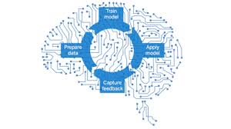

============================================================== SUPERVISED LEARNING =============================================================

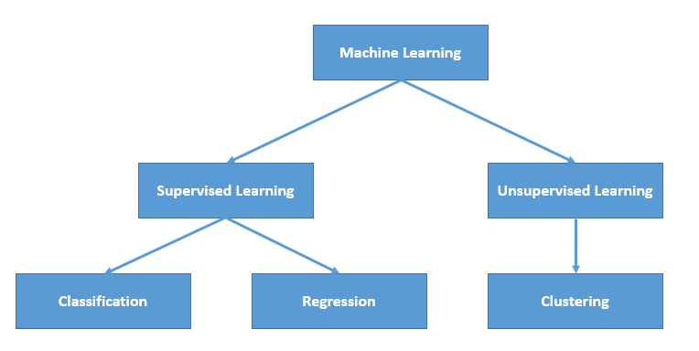

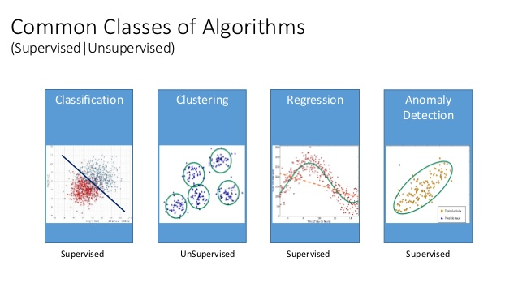
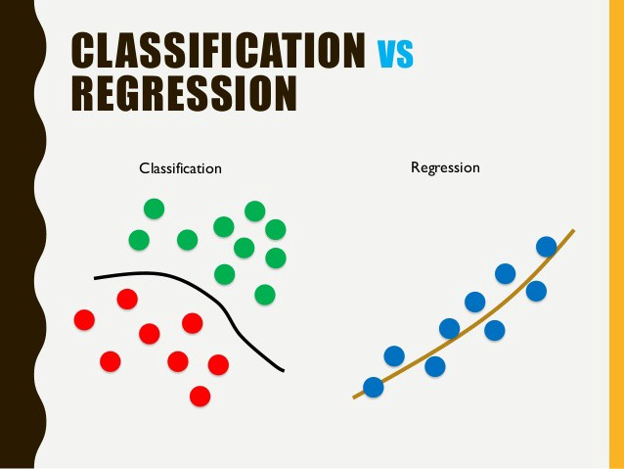

In supervised learning, we are given a data set and already know what our correct output should look like, having the idea that there is a relationship between the input and the output.

Supervised learning problems are categorized into "regression" and "classification" problems. In a regression problem, we are trying to predict results within a continuous output, meaning that we are trying to map input variables to some continuous function. In a classification problem, we are instead trying to predict results in a discrete output. In other words, we are trying to map input variables into discrete categories.

Example 1:

Given data about the size of houses on the real estate market, try to predict their price. Price as a function of size is a continuous output, so this is a regression problem.

We could turn this example into a classification problem by instead making our output about whether the house "sells for more or less than the asking price." Here we are classifying the houses based on price into two discrete categories.

Example 2:

(a) Regression - Given a picture of a person, we have to predict their age on the basis of the given picture

(b) Classification - Given a patient with a tumor, we have to predict whether the tumor is malignant or benign.

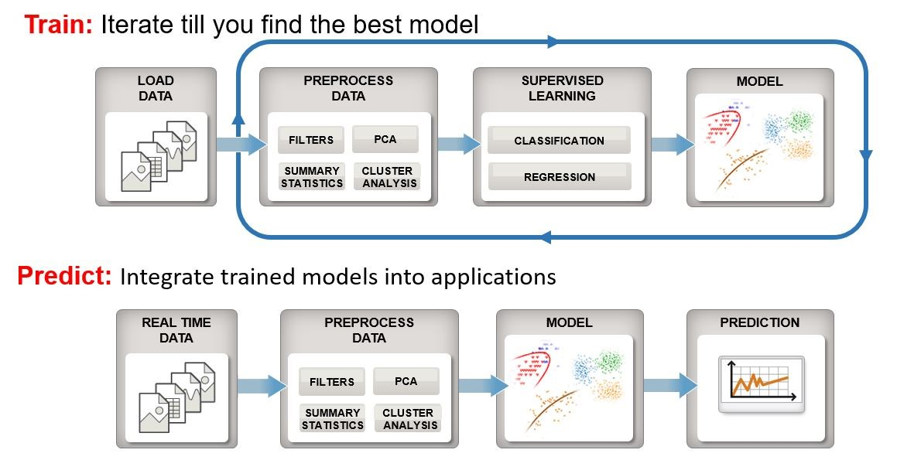

============================================================== SUPERVISED LEARNING =============================================================

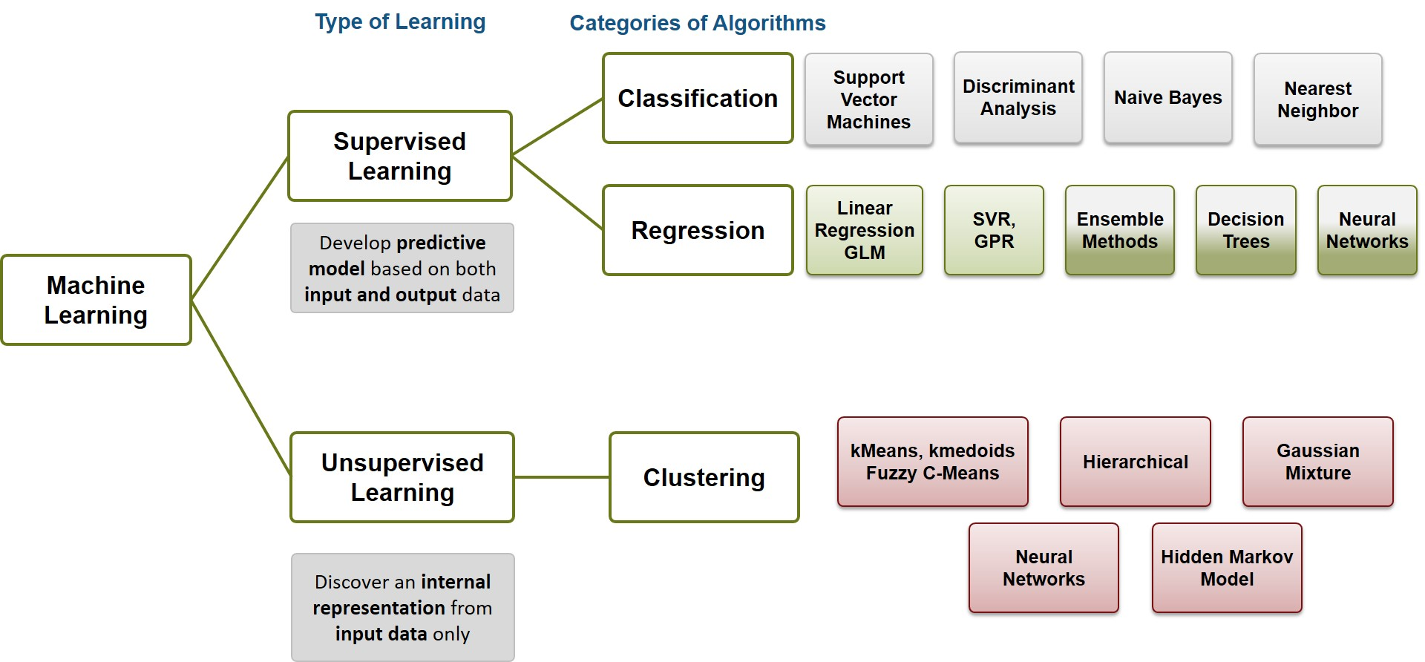

upervised learning splits into two broad categories: classification and regression.
- In classification, the goal is to assign a class (or label) from a finite set of classes to an observation. That is, responses are categorical variables. Applications include spam filters, advertisement recommendation systems, and image and speech recognition. Predicting whether a patient will have a heart attack within a year is a classification problem, and the possible classes are true and false. Classification algorithms usually apply to nominal response values. However, some algorithms can accommodate ordinal classes
- In regression, the goal is to predict a continuous measurement for an observation. That is, the responses variables are real numbers. Applications include forecasting stock prices, energy consumption, or disease incidence.

============================================================== UNSUPERVISED LEARNING =============================================================

Unsupervised Learning

Unsupervised learning allows us to approach problems with little or no idea what our results should look like. We can derive structure from data where we don't necessarily know the effect of the variables.

We can derive this structure by clustering the data based on relationships among the variables in the data.

With unsupervised learning there is no feedback based on the prediction results.

Example:

Clustering: Take a collection of 1,000,000 different genes, and find a way to automatically group these genes into groups that are somehow similar or related by different variables, such as lifespan, location, roles, and so on.

Non-clustering: The "Cocktail Party Algorithm", allows you to find structure in a chaotic environment. (i.e. identifying individual voices and music from a mesh of sounds at a cocktail party).

============================================================== UNSUPERVISED LEARNING =============================================================

To establish notation for future use, we’ll use x(i) to denote the “input” variables (living area in this example), also called input features, and y(i) to denote the “output” or target variable that we are trying to predict (price). A pair (x(i),y(i)) is called a training example, and the dataset that we’ll be using to learn—a list of m training examples (x(i),y(i));i=1,...,m—is called a training set. Note that the superscript “(i)” in the notation is simply an index into the training set, and has nothing to do with exponentiation. We will also use X to denote the space of input values, and Y to denote the space of output values. In this example, X = Y = ℝ.

To describe the supervised learning problem slightly more formally, our goal is, given a training set, to learn a function h : X → Y so that h(x) is a “good” predictor for the corresponding value of y. For historical reasons, this function h is called a hypothesis. Seen pictorially, the process is therefore like this:

When the target variable that we’re trying to predict is continuous, such as in our housing example, we call the learning problem a regression problem. When y can take on only a small number of discrete values (such as if, given the living area, we wanted to predict if a dwelling is a house or an apartment, say), we call it a classification problem.

============================================================== Challanges in Machine Learning
=============================================================
Data comes in all sizes and shapes:

Real-world datasets can be messy, incomplete, and in a variety of formats. You might just have simple numeric data. But sometimes you’re combining several different data types, such as sensor signals, text, and streaming images from a camera

Preprocessing your data might require specialized knowledge and tools.:
For example, to select features to train an object detection algorithm requires specialized knowledge of image processing. Different types of data require different approaches to preprocessing.

It takes time to find the best model to fit the data. Choosing the right model is a balancing act :
Highly flexible models tend to overfit data by modeling minor variations that could be noise. On the
other hand, simple models may assume too much. There are always tradeoffs between model speed, accuracy, and complexity.

==============================================================
Steps in Supervised Machine Learning
=============================================================

Prepare Data

Choose an Algorithm

Fit a Model

Choose a Validation Method

Examine Fit and Update Until Satisfied (Iterate among all the models)

Use Fitted Model for Predictions
